Environmental Literacy Carbon Assessment:
--- Elementary School Level, Form B ---

Science is easier to understand if you can make connections between what you know now and the new ideas that you are studying. This is a test that will help us understand what you know now. Please answer these questions as carefully and completely as you can. If you are not sure of the answer, please write about any ideas that you have. If you can help us to understand how you think about these questions, then we can do a better job of explaining science in ways that make sense to you.

Please put your initials (not your full name) in the boxes
Date ________________ | First | Middle | Last

Class ____________________________ Teacher _______________________

1. Which of the following is/are energy source(s) for plants? Circle yes or no for each of the following.

a. Water Yes / No
b. Light Yes / No
c. Air Yes / No
d. Nutrients in soil Yes / No
e. Plants make their own energy. Yes / No

Please explain ALL your answers, including why the things you circled “No” for are NOT sources of energy for plants.

2. Humans must eat and breathe in order to live and grow. Are eating and breathing related to each other? (Circle one)

YES NO

If you circled “Yes” explain how eating are breathing are related. If you circled “No” then explain why they are not related. Give as many details as you can.

3. When the baby was five months old, she weighed 15 lb. After 7 years, the tiny baby has grown into a big girl, weighing 50 lb.
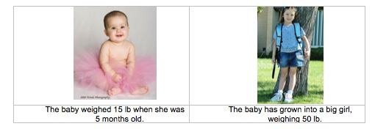
a. Why can the living baby grow and gain more and more weight, but a non-living toy baby cannot? What is special about what the living baby can do that the toy baby cannot do?

b. Do you think the baby girl will need any of the following things to grow and gain weight? Please circle Yes or No and explain your choice.

Things | Does the girl need it to grow? | If you circle yes, how does it help the girl’s body to grow?  If you circle no, explain why the girl does not need it to grow.
Sunlight | Yes No
Water | Yes No
Air | Yes No
Food | Yes No

4. How do you think the foods you eat can help you move your little finger?
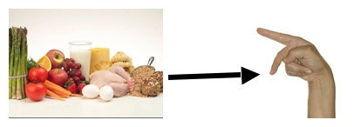
Please explain as much as you can about how foods you eat help you move your little finger.

5. During winter, many animals have problems finding food and may hibernate (sleep through the winter). These animals lose weight by spring. What do you think happens to the fat that the animal lost during hibernation? Circle True OR False for each thing in the list below.

True | False | The fat was turned into heat to keep their bodies warm during the winter
True | False | The fat was turned into water and gases and given off by the animal
True | False | The fat was turned into waste in the digestive system and left the body as poop
True | False | The fat was turned into other materials in the body that don't weigh as much.
True | False | Something else happened to the fat:_____________________________  __________________________________________________________

Think about your responses above. Please explain as much as you can about what happens to the fat in the animal’s body during hibernation.

6. When leaves in a compost pile decay, they lose mass (and weight).

a. What do you think happens to the materials that once made up the leaves? Choose the BEST answer from the list below.

- The materials go away when the leaves decompose.
- The materials change to heat energy.
- The materials change into soil minerals.
- The materials change into gases that go into the air.

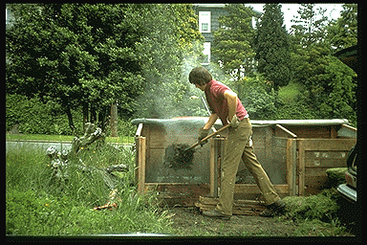
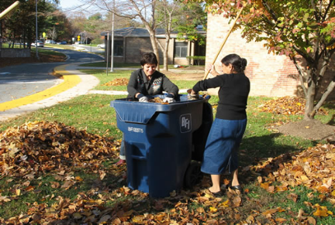

Picture 1 Picture 2

b. In autumn, people pile fallen leaves and send them to the trash dump (Picture 1). Picture 2 shows that after several weeks, heat is released from the leaves. (The leaves are not on fire.) Where does the heat come from?

7. Jared, the Subway® man, lost a lot of weight by eating low calorie subway sandwiches. Where did the mass of his fat go (how was it lost)?
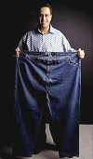

8. When you turn on a lamp, you can see the light. Where does the light energy come from? Trace the energy back as far as you can. You may or may not fill up all of the spaces in the table.

What form of energy was it? Where was it?
Light energy of the light

Before that…
Before that…
Before that…
Before that…
Before that…

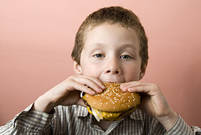 | 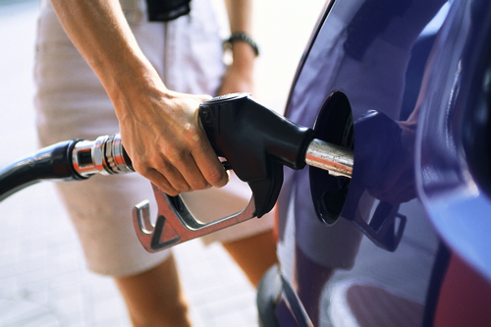 | 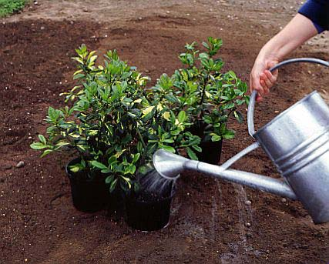
A. Eating a hamburger | B. Filling up a car with gasoline | C. Watering plants

9. The pictures above show three things happening. A science teacher says that A and B are similar events, but picture C is different from A and B. What reason do you think the science teacher might have for saying that?

10. You are playing outside in a cold winter. You find a stone on the ground. When you pick up the stone, you find that the stone is very cold. Why can people keep warm on a cold day, but a stone cannot? Please choose all the choices that you think are correct.

True | Circle True or False | If you choose True, please explain why you think it is correct.
Because only people and animals can stay warm. | True  False
Because people are wearing clothes, but the stone is not. | True  False
Because people can run and the stone cannot. | True  False
Because people eat food. | True  False

11. A small acorn grows into a large oak tree. Where does most of the weight of the oak tree come from? (Circle the best explanation from the list below).

A. From the natural growth of the tree
B. From carbon dioxide in the air and water in the soil
C. From water and nutrients that the tree absorbs through its roots
D. From sunlight that the tree uses for food.

